# Technical Design Document: Programming_Exercise_2

# Name: Christian Innes
# Date: September 20, 2026
# Program Description: Checks emails & other text for commonly found spam wordage

## Function: check_for_spam
Calls for the function to take the text, check a set of words, make text lower case, and flag any that are found in the set.

##Parameters:

(text): stores the text entered

##Variables:

text_fixer: Make the text lowercase
spam: A set of words used to check for spam
email_checker: Checks the total number of words
flagged_wordage: A list of all the words that were flagged for spam found in the spam set
total_spam_wordage: the number of words that are found in the spam set
total_spam_percentage: The Percentage of the total words count that was found to be spam

##Logic:
convert to lowercase
remove punctuation
Make into individual words
Check for no words
If no words give result
If not compare each word to potential spam set
Store any flagged words
Count the amount of flagged words
Make flagged words into percentage
Round it to nearest decimal point
Return findings

##Return:
Returns with the toal number of words used, the number that was spam, the percentage, and the list of the flagged words.

## Function: get_spam_level
Displays the likelihood that the email or text is spam

##Parameters:

spam_percentage: Percentage of words identified as spam

##Variables:

spam_percentage: Percentage of words that are used to find the level of spam

##Logic:

Check if equal to 0
If equal to 0 then return "No spam found"
check if less than 25
If less than 25 then return "Maybe Spam"
If less than 50 then return "Most likely Spam"
If greater than 50 return "Found to be Spam"

##Return:
Gives a description of the level of spam found to be based on the percentage of spam previously found

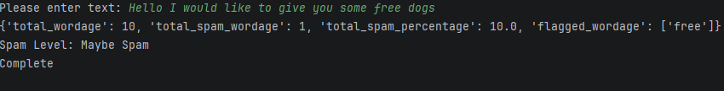

#Link to your repository: https://github.com/monky6676/COP2373

